**DEPLOYING SPRINGBOOT PROJECT INTO PRODUCTION SERVER**

**Create one Spring starter Project**

**Project Name: DeploymentProject**

**Dependencies: Spring Web**

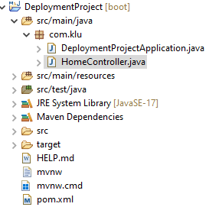

**HomeController.java**

**import** org.springframework.web.bind.annotation.GetMapping;

**import** org.springframework.web.bind.annotation.RestController;

@RestController

**public** **class** HomeController

{

@GetMapping({"/", "/home", "/status"})

**public** String getStatus()

{

**return** "Application is up and Running..";

}

}

**Create a jar file in the target folder by executing: $mvn clean package**



**With command .jar file automatically added to the target folder in the spring project.**

**Run the Project and test it.**

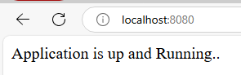

**Push this Springboot project to the Github**

**Create a New Repository in the github with the name “DeploymentDemo”**

**Goto command prompt and set the path where is your springboot project (DeploymentProject) is available**

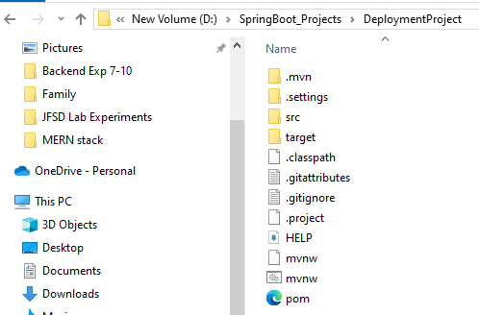

**Git init**

**Git add .**

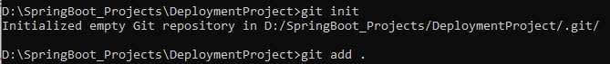

**Git commit –m “ok”**

**Git remote add origin https://github.com/lakshminarayana-kodavali/DeploymentDemo.git**

**Git push –u origin master**

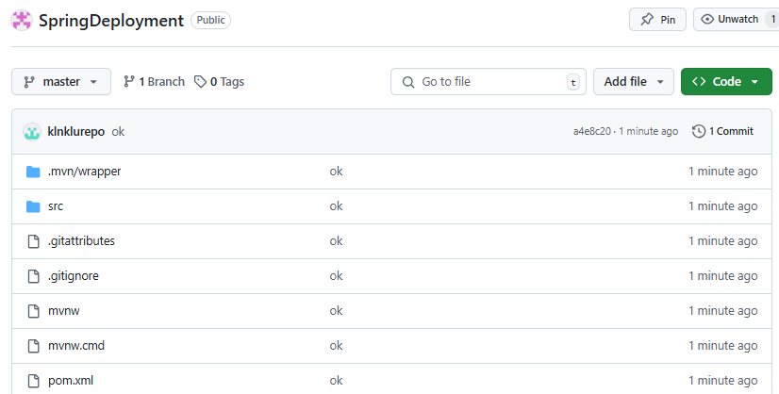

**Login into RailwayApp (** [**https://railway.com/**](https://railway.com/) **) and SignIn**

**Click on the “New Project” and choose “Deploy from GitHub repo” (first option)**

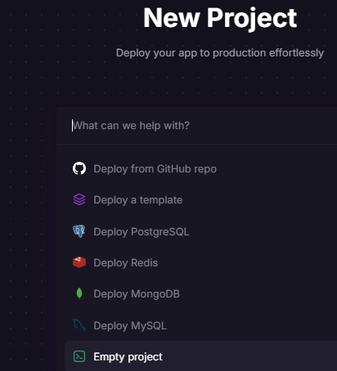

### ****Connect to GitHub Repository****

* Select your Spring Boot repository.

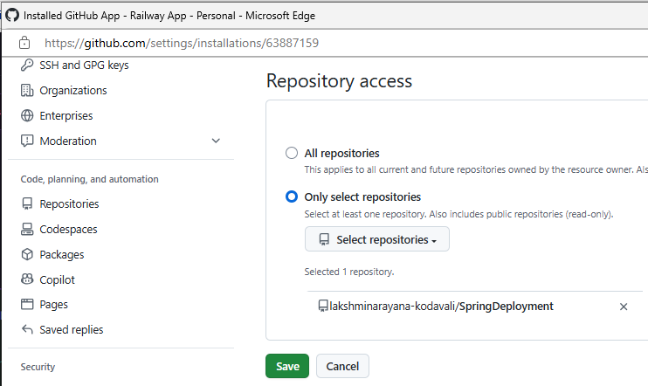

## **Deploy & Test:** Click **Deploy** and wait for the build to complete.

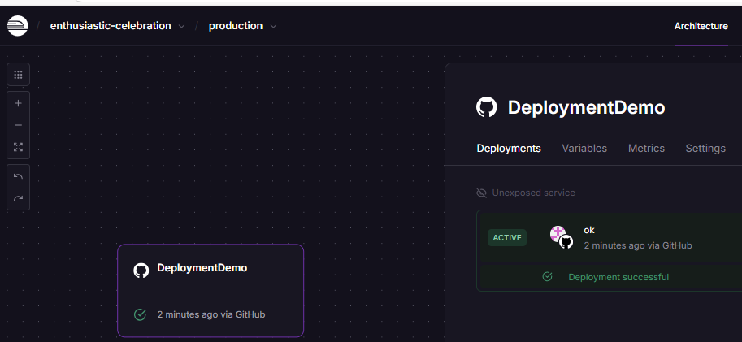

**We can get Railway URL from the Settings -> Networking -> Generate Domain**

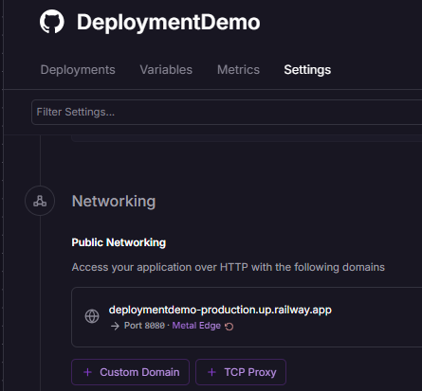

**Run this deployed project from the browser using Railway URL**

